Transformations: A Wellness Collective

Massage Therapy Intake Form

Personal Information
Name: ___________________________________ Occupation: _________________________
Address: __________________________ City: _________________State: _____ Zip: ___________
Daytime Phone: (_____) _________________ Evening Phone: (_____) __________________
Email Address: __________________________________________________ DOB: _____________
Emergency Contact: ________________________________ Phone: (_____) __________________

Massage Experience
How did you hear about us? _________________________________________________________
Have you ever had a professional massage before? Y / N
If yes, when was your last massage? __________________________________________________
What type of massage? (ex. Swedish, Deep Tissue, etc) __________________________________
What is your goal for today? ________________________________________________________
What type of pressure do you like? (Please Circle) Light----Medium----Firm----Deep
Are you uncomfortable with any of the following areas to be massaged:
Gluteal Region (Y/N) Pectoral Region (Y/N) Face/Scalp (Y/N) Feet (Y/N)

Health History
Please list any medications or supplements you are currently taking and explain: _________________________________________________________________________________

Please list any injuries/accidents/illnesses still affecting you: _______________________________
_________________________________________________________________________________

Please list any surgeries and explain: __________________________________________________
_________________________________________________________________________________
Please identify the areas of concern on the chart below:
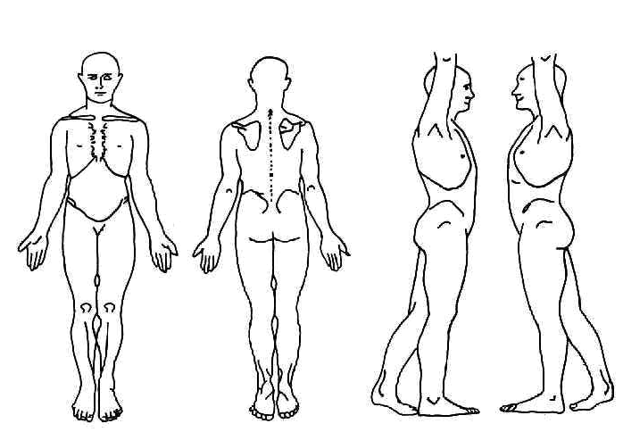
Health History
Please circle Current or Past

Current Past | Add/Adhd? Autistic? Aspergers? | Current Past | High/ Low Cholesterol
Current Past | Allergies | Current Past | HIV/AIDS
Current Past | Alzheimer’s Disease | Current Past | Infection: Type?
Current Past | Anxiety Disorder | Current Past | Lupus
Current Past | Arthritis: Osteoarthritis? Rheumatoid? | Current Past | Lymphedema
Current Past | Athletes Foot | Current Past | Mononucleosis
Current Past | Asthma | Current Past | Multiple Sclerosis
Current Past | Blood Clot/ Deep Vein Thrombosis/ | Current Past | Muscular Dystrophy
Current Past | Broken or fractured bones | Current Past | Numbness/ Tingling: Area?
Current Past | Bursitis | Current Past | Osteoporosis/Osteopenia
Current Past | Cancer: Location | Current Past | Pain? Location?
 | Treatment: |  | Muscular or Joint? Chronic?
 | In Remission Y/N | Current Past | Paralysis
Current Past | Carpal Tunnel Syndrome | Current Past | Phlebitis/ Embolism
Current Past | Cerebral Palsy | Current Past | Pregnancy
Current Past | Chronic Fatigue Syndrome | Current Past | Psoriasis
Current Past | Contagious condition | Current Past | Rash
Current Past | Crohn’s disease | Current Past | Sciatica
Current Past | Depression | Current Past | Scoliosis
Current Past | Diabetes Type I Type 2 | Current Past | Seizure
Current Past | Diverticulitis | Current Past | Sleeping problems
Current Past | Eczema | Current Past | Spasms/ Cramping
Current Past | Epilepsy | Current Past | Strain/ Sprain
Current Past | Fertility Concerns | Current Past | Stroke
Current Past | Fibromyalgia | Current Past | Tendonitis
Current Past | General Fatigue | Current Past | Thyroid issues
Current Past | Gout | Current Past | TMJ/ Jaw Pain
Current Past | Headaches Location: | Current Past | Tumor: Location?
 | Frequency? |  | Malignant or Benign?
Current Past | Hearing Impairment | Current Past | Varicose Veins
Current Past | Heart Condition | Current Past | Visually impaired
Current Past | Herpes/ Shingles | Current Past | Other
Current Past | High/ Low Blood Pressure

Release Form

By signing this, I agree that I have answered all questions to the best of my knowledge and that I will inform the therapist of any changes in my condition or medication. If I experience any pain/discomfort or would like the pressure adjusted, I will inform the therapist immediately.

I understand that a massage therapist cannot diagnosis any illness, disease, or any physical or mental disorders nor can the therapist prescribe any medication and that nothing said in a session should be construed as such. I understand that massage therapy is intended to work in conjunction with my health care, not act as a substitute for medical examination. I understand that it is my responsibility to consult a physician for any ailments I may have.

I understand that massage therapy is a therapeutic measure used to reduce stress, muscular tension, and pain. I understand there are no guarantees for recovery and if I am unsatisfied with the progress made with my treatment I will inform the therapist, so he/she may direct me to another treatment

I agree to abide by a 24 hour cancellation notice for any scheduled massage. I understand I may be charged up to the full amount of service for missed appointments or for any cancellations with less than a 24 hour notice. I understand that if I arrive late for an appointment, the session will end at the original scheduled time to prevent penalizing another client. However, if the massage therapist is late, he/she will fulfill the scheduled massage length or offer a reasonable compensation.

I understand that if I use a coupon during my visit, it is not valid with any other coupons or promotions.

I agree that I am of legal age (18 years old) and that if I am not, I agree to have my parent or guardian sign a parental/guardian release form before treatment.

I understand that certain conditions or medications may contraindicate (not permit) massage or may require the use of alternate techniques or pressure. I respect the decision of the massage therapist and am fully prepared to reschedule the massage for a later date if requested by the massage therapist. I also understand that massage may be advisable by my physician, but not by a massage therapist. In that event, I agree to provide a written agreement from my physician before proceeding with treatment.

Print Name: __________________________________________________________________

Signature: ____________________________________________________________________

If Minor: Parental Consent

Parent Signature: ____________________________________________________________________

Date: ________________________________________________________________________

